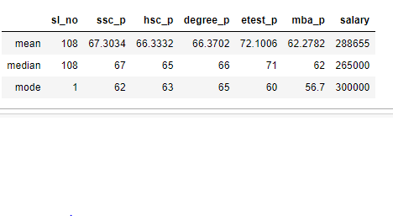

Placement:

1.Sslc Mark Average(Mean)=67

2. Hsc Mark Average(Mean)=66

3. Degree Mark Average(Mean)=66

4. Entrance Mark Average(Mean)=72

5. MBA Mark Average(Mean)=62

Salary =288655

1.Sslc Mark Average(Median)=67

2. Hsc Mark Average(Median)=65

3. Degree Mark Average(Median)=66

4. Entrance Mark Average(Median)=71

5. MBA Mark Average(Median)=62

Salary: 265000

1.Sslc Student Getting the Mark range is(Mode)=62

2. Hsc Student Getting the Mark range is(Mode)=63

3. Degree Student Getting the Mark range is(Mode)=65

4. Entrance Mark Student Getting the Mark range is(Mode)=60

5. MBA Student Getting the Mark range is(Mode)=56.7

Salary: 300000(student getting this salary)